# Creating a New MEAN Application

# Step 1. Create a new MEAN project.

To create a new MEAN project, create a new folder for your project in the */home/bitnami* directory and then create a new Express project:

cd /home/bitnami

mkdir projects

cd projects

express sample

cd sample

npm install

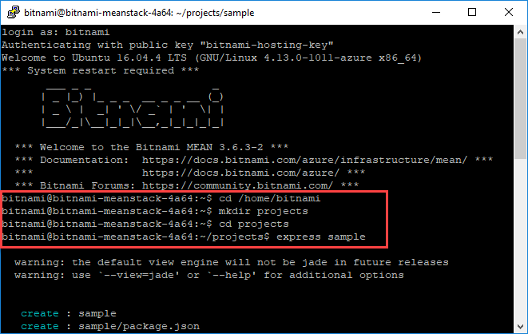

To start the application, type: ./bin/www

./bin/www

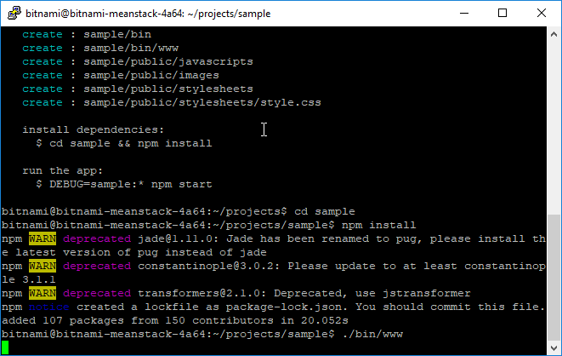

By default, the application will run on port 3000.

To access the application and see its output, browse to *http://localhost:3000/*.

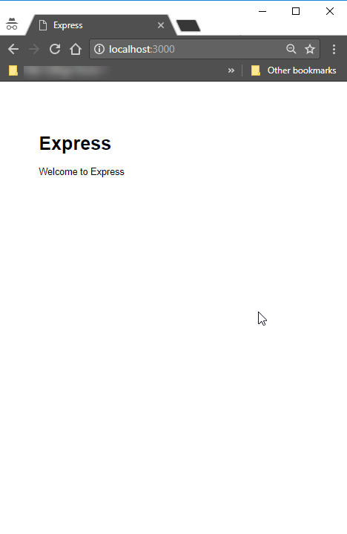

To end the application, terminate the running Express process.